**LAB 07**

**CONDITIONAL PROCESSING**





EL

2003

COMP ORG & ASSEMBLY

LANGUAGE

LAB

LABORATORY MANUAL



Fall 2021



Instructor:

Aamir Ali

, Aashir Mehboob, Amin Sadiq, Qurat

-

ul

-

Ain, M Kariz, Rabia

Syed Muhammad Faheem 20K-1054 3E

STUDENT NAME ROLL NO SEC

______________________________________

SIGNATURE & DATE

# MARKS AWARDED: ______________

___________________________________________________________________

**NATIONAL UNIVERSITY OF COMPUTER AND EMERGING SCIENCES**

**(NUCES), KARACHI**

Version: 1.0

Prepared by: Aashir Mahboob th

Date: 27 Oct 2021

# Lab Session 07: CONDITIONAL PROCESSING

**Objectives:**

* Boolean Instructions

* Set Operations
* CMP Instruction
* Conditional Jumps

**Boolean Instructions**

## • AND

Boolean AND operation between a source operand and destination operand.

**Syntax:** *AND reg, reg*

*AND reg, mem*

*AND reg, imm*

*AND mem, reg*

*AND mem, imm*

## • OR

Boolean OR operation between a source operand and destination operand.

**Syntax:** *OR reg, reg*

*OR reg, mem*

*OR reg, imm*

*OR mem, reg*

*OR mem, imm*

## • XOR

Boolean XOR operation between a source operand and destination operand.

**Syntax:** *XOR reg, reg*

*XOR reg, mem*

*XOR reg, imm*

*XOR mem, reg*

*XOR mem, imm*

## • NOT

Boolean NOT operation on a destination operand.

**Syntax:** *NOT reg*

*NOT mem*

## • TEST

Similar to AND operation, except that instead of affecting any operands it sets the FLAGS appropriately.

**Syntax:** *TEST reg, reg*

*TEST reg, mem*

*TEST reg, imm*

*TEST mem, reg*

*TEST mem, imm*

**Example 01:**

Include Irvine32.inc

.code main proc

|  |  |  |
| --- | --- | --- |
| mov | al, 10101110b | ; Clear only bit 3 |
| and | al, 11110110b | ; AL = 10100110 |
| mov | al, 11100011b | ; set bit 2 |
| or | al, 00000100b | ; AL = 11100111 |
| mov | al, 10110101b | ; 5 bits means odd parity |
| xor | al, 0 | ; PF = 0 (PO) |
| mov | al, 10100101b | ; 4 bits means even parity |
| xor | al, 0 | ; PF = 1 (PE) |
| mov | al, 11110000b |  |
| not | al | ; AL = 00001111b |
| mov | al, 00100101b |  |
| test | al, 00001001b | ; ZF = 0 |
| mov | al, 00100101b |  |
| test | al, 00001000b | ; ZF = 1 |
| call DumpRegs  exit  main ENDP END main | |

# Set Operations (using Boolean instructions)

* **Set Complement**

The complement of a set can be achieved through NOT instruction.

* **Set Intersection**

The intersection of two sets can be achieved through AND instruction.

## • Set Union

The union of two sets can be achieved through OR instruction.

**Example 02:**

Include Irvine32.inc

.data

A DWORD 10000000000000000000000000000111b B DWORD 10000001010100000000011101100011b msg1 BYTE "A intersection B is: ", 0 msg2 BYTE "A union B is: ", 0

msg3 BYTE "Complement of A is: ", 0

.code main proc

|  |  |
| --- | --- |
| mov | eax,A |
| and | eax, B ; A intersection B |
| mov | edx, OFFSET msg1 |
| call | WriteString |
| mov | ebx, TYPE DWORD |
| call | WriteBinB |
| call | Crlf |
| mov | eax, A |
| or | eax, B ; A union B |
| mov | edx, OFFSET msg2 |
| call | WriteString |
| mov | ebx, TYPE DWORD |
| call | WriteBinB |
| call | Crlf |
| mov | eax, A |
| not | eax ; A complement |
| mov | edx, OFFSET msg3 |
| call | WriteString |
| mov | ebx, TYPE DWORD |
| call | WriteBinB |

call DumpRegs exit

main ENDP END main

# CMP instruction

CMP (compare) instruction performs an implied subtraction of a source operand from a

destination operand for comparison.

For unsigned operands:

* Destination < source ZF = 0 CF = 1
* Destination > source ZF = 0 CF = 0
* Destination = source ZF = 1 CF = 0

For signed operands:

* Destination < source SF ! = OF
* Destination > source SF = OF
* Destination = source ZF = 1

**Example 03:**

Include Irvine32.inc

.code

main proc

mov ax, 5

cmp ax, 10 ; ZF = 0 and CF = 1

mov ax, 1000

cmp ax, 1000 ; ZF = 1 and CF =0

mov si, 106

cmp si, 0 ; ZF = 0 and CF = 0

call DumpRegs

exit

main ENDP

END main

# Conditional Jumps

•

**Jumps based on Flag values**

•

**Jumps based on Equality**

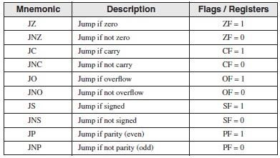

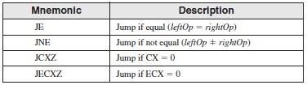

## • Jumps based on unsigned comparisons

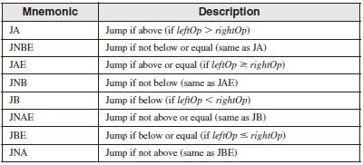

## • Jumps based on signed comparisons

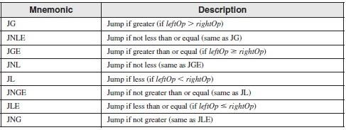

**Example 04:**

Include Irvine32.inc

.data

var1 DWORD 250 var2 DWORD 125 larger DWORD ?

.code main proc

|  |  |
| --- | --- |
| mov | eax, var1 |
| mov | larger, eax |
| mov | ebx, var2 |
| cmp | eax, ebx |
| jae | L1 |
| mov | larger, ebx |

L1: call DumpRegs exit

main ENDP

END main

**Example 05:**

Include Irvine32.inc

.data

var1 DWORD 50 var2 DWORD 25 var3 DWORD 103

msg BYTE "The smallest integer is: ", 0

.code main proc mov eax, var1

cmp eax, var2 jbe L1

|  |  |  |
| --- | --- | --- |
| mov eax, var2 L1:    cmp eax, var3  jbe L2 mov eax, var3    L2:  mov edx, OFFSET msg | |  |
| call WriteString call WriteDec  call DumpRegs exit  main ENDP  END main  **Example 06:**    Include Irvine32.inc  .data  char BYTE ?  .code main proc L1: |  |
| mov eax, 10 call Delay |  | ; create 10ms delay |
| call ReadKey |  | ; reads a key input |
| jz L1 |  | ; repeat if no key is pressed |
| mov char, al call DumpRegs exit  main ENDP END main | ; saves the character | |

**Lab Task(s):**

1. Translate the following pseudo-code to Assembly Language:

**var = 5**

**if ( var<ecx ) AND (ecx>=edx) then x = 0 else x = 1**

1. Use cmp and jumps to find the first non-zero value in the given array:

**intArr SWORD 0, 0, 0, 0, 1, 20, 35, -12, 66, 4, 0**

1. Write a program that takes four input integers from the user. Then compare and display a message whether these integers are equal or not.

1. Write a program for sequential search. Take an input from the user and find if it occurs in the following array:

**arr WORD 10, 4, 7, 14, 299, 156, 3, 19, 29, 300, 20**

1. Translatethe followingpseudo-codeto Assembly Language:

**Swap_Count = 0**

**for all elements of list**

**if list[i] > list[i+1] swap(list[i], list[i+1]) Swap_Count = Swap_Count + 1**

**end if**

**end for Print Swap_Count**

**Task 1:** 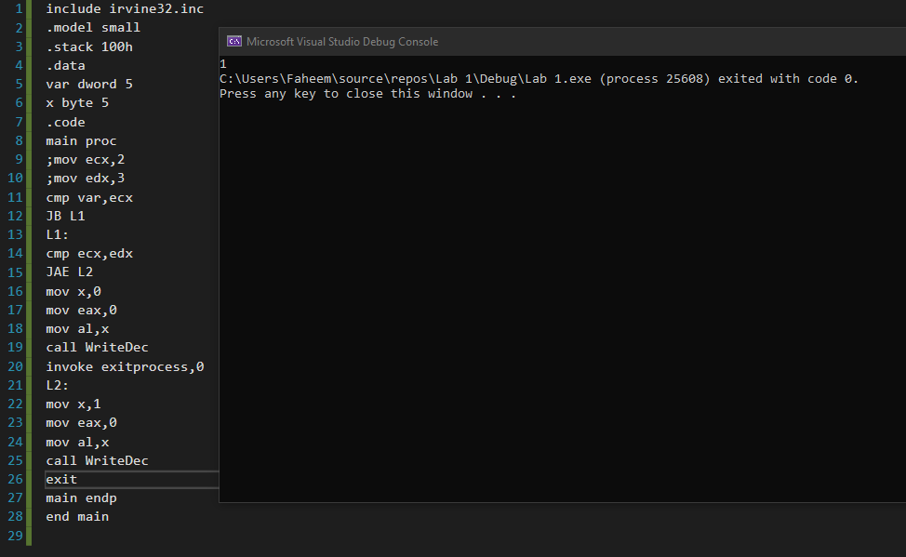

**Task 2:** 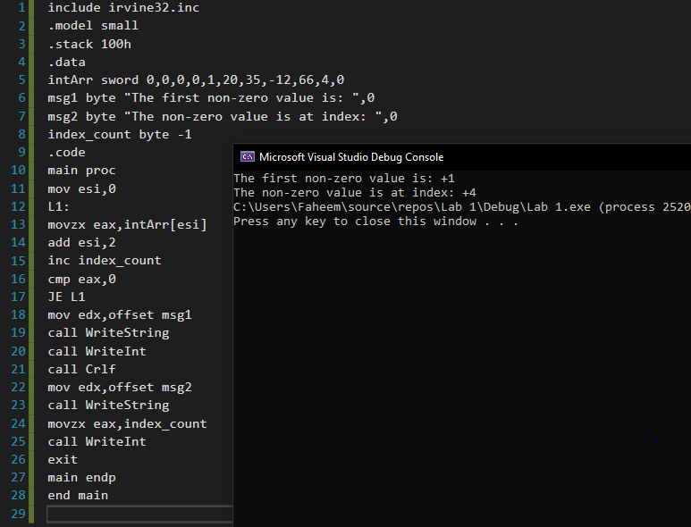

**Task 3:** 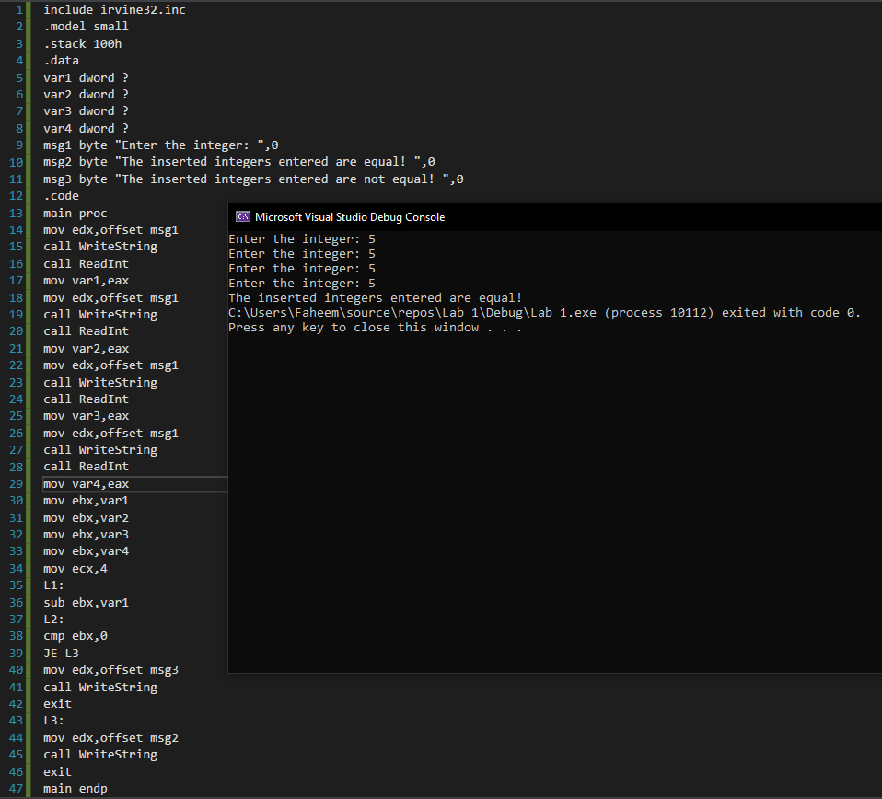

**Task 4:** 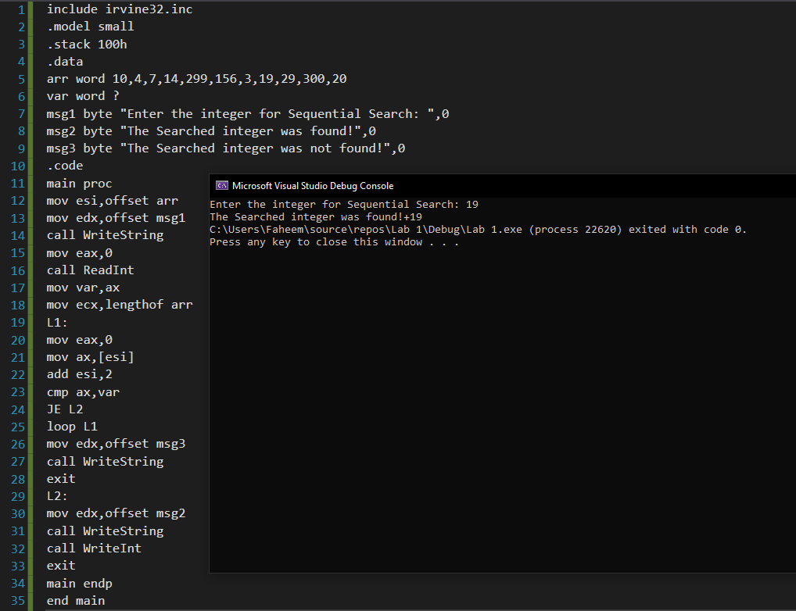

**Task 5:** 